

TRIDA

THIRUVANANTHAPURAM DEVELOPMENT AUTHORITY
Thiruvananthapuram

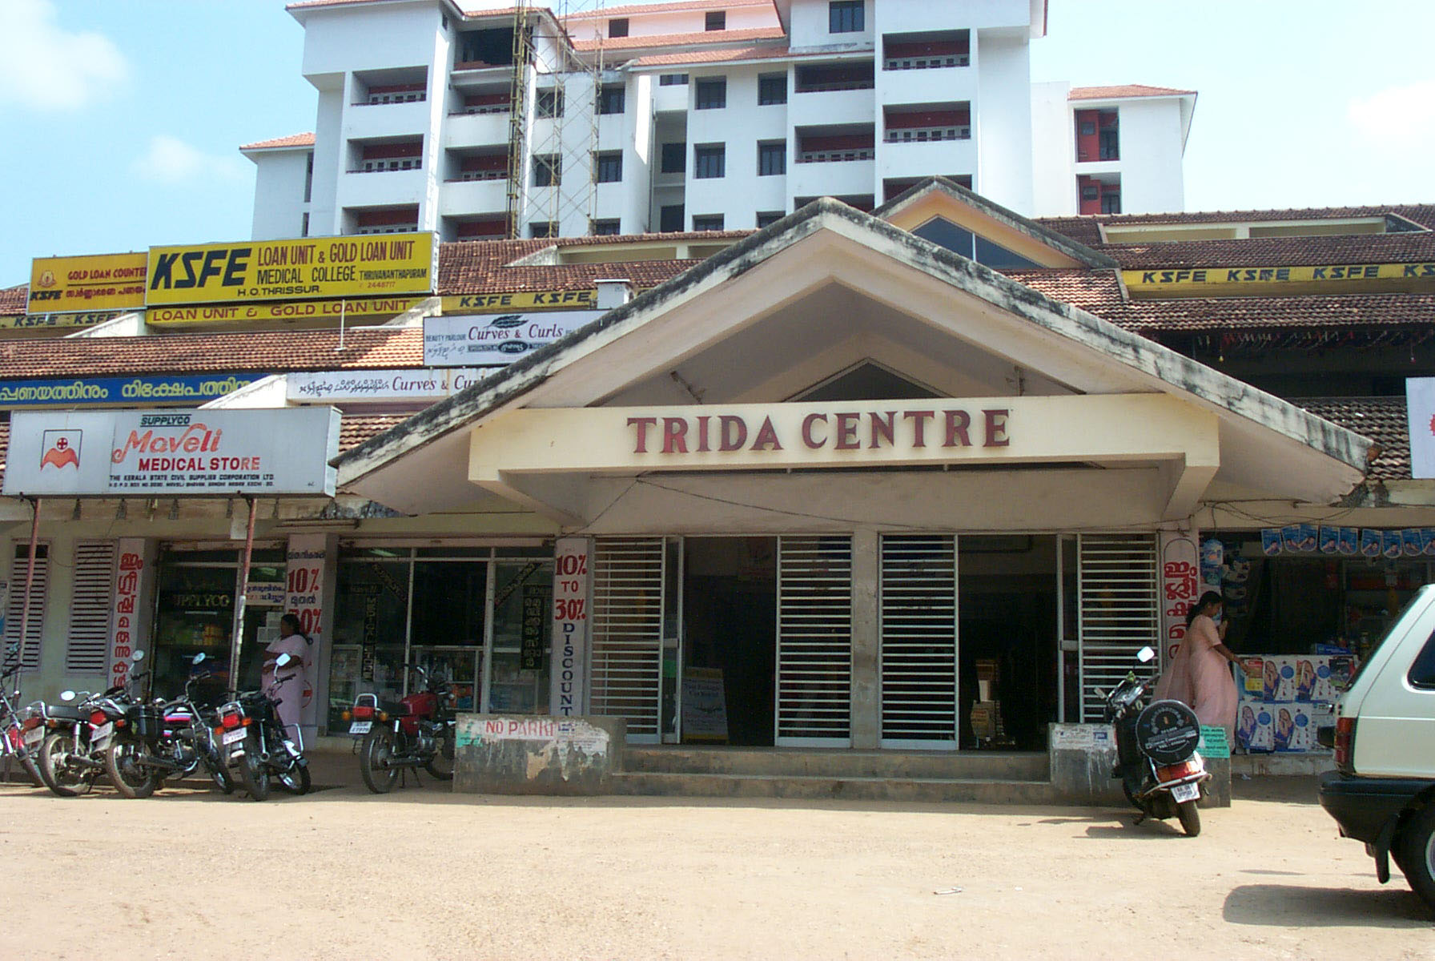
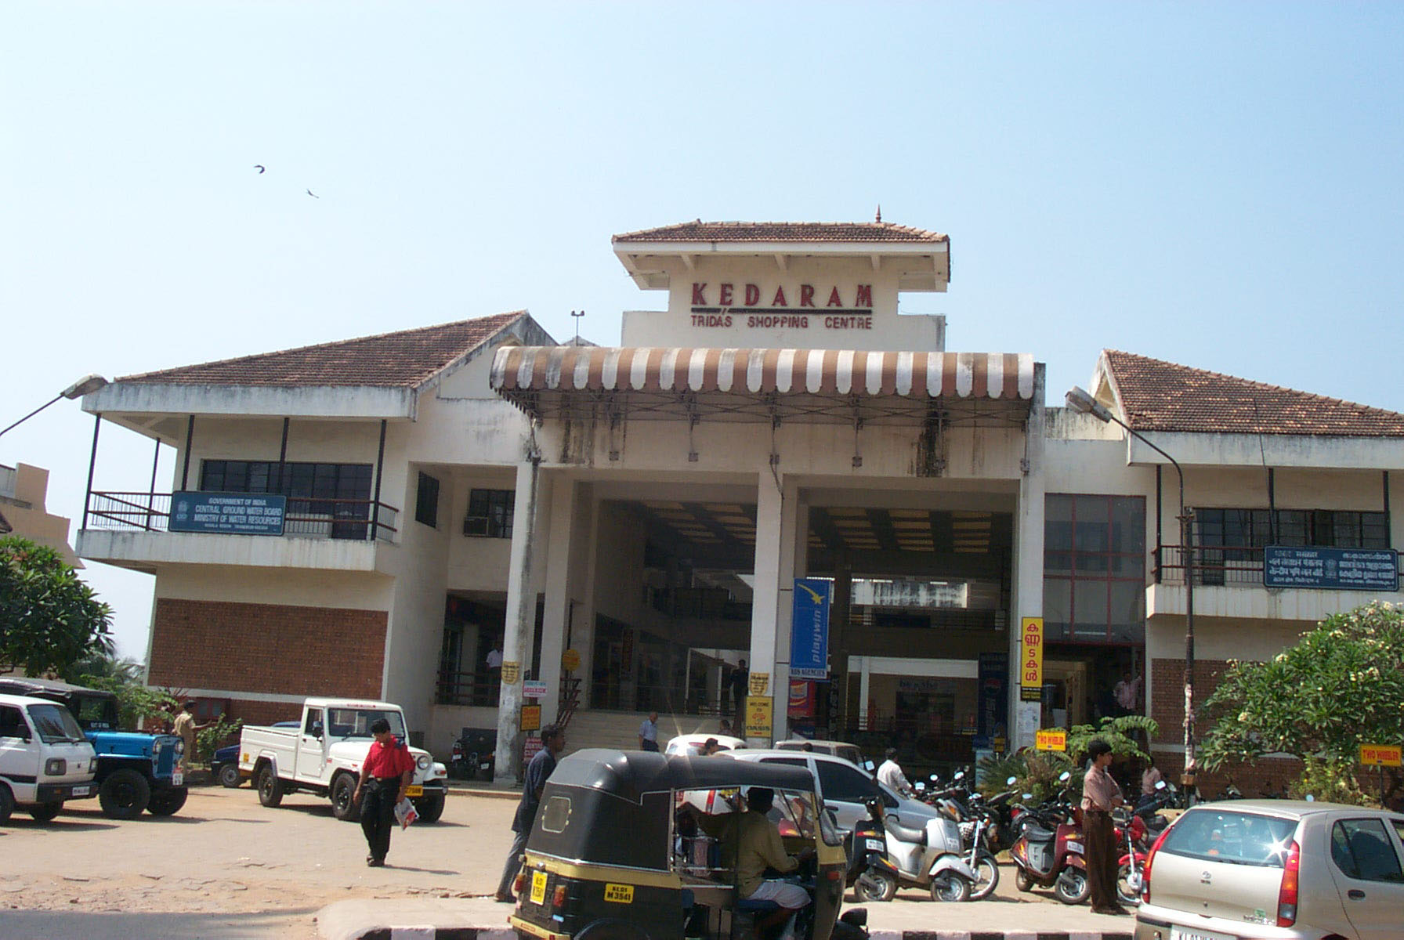
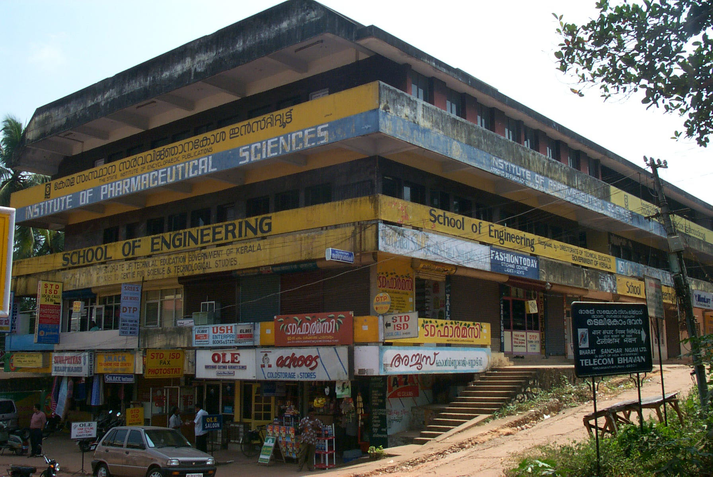
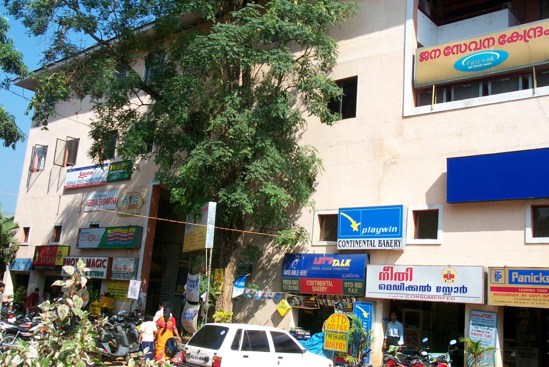
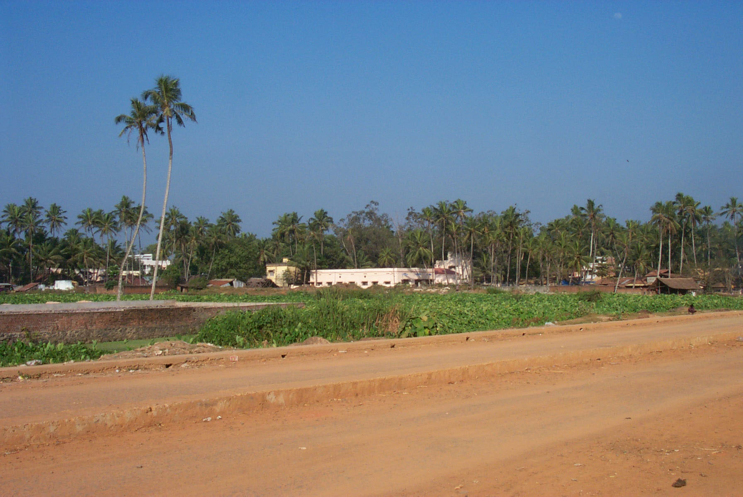
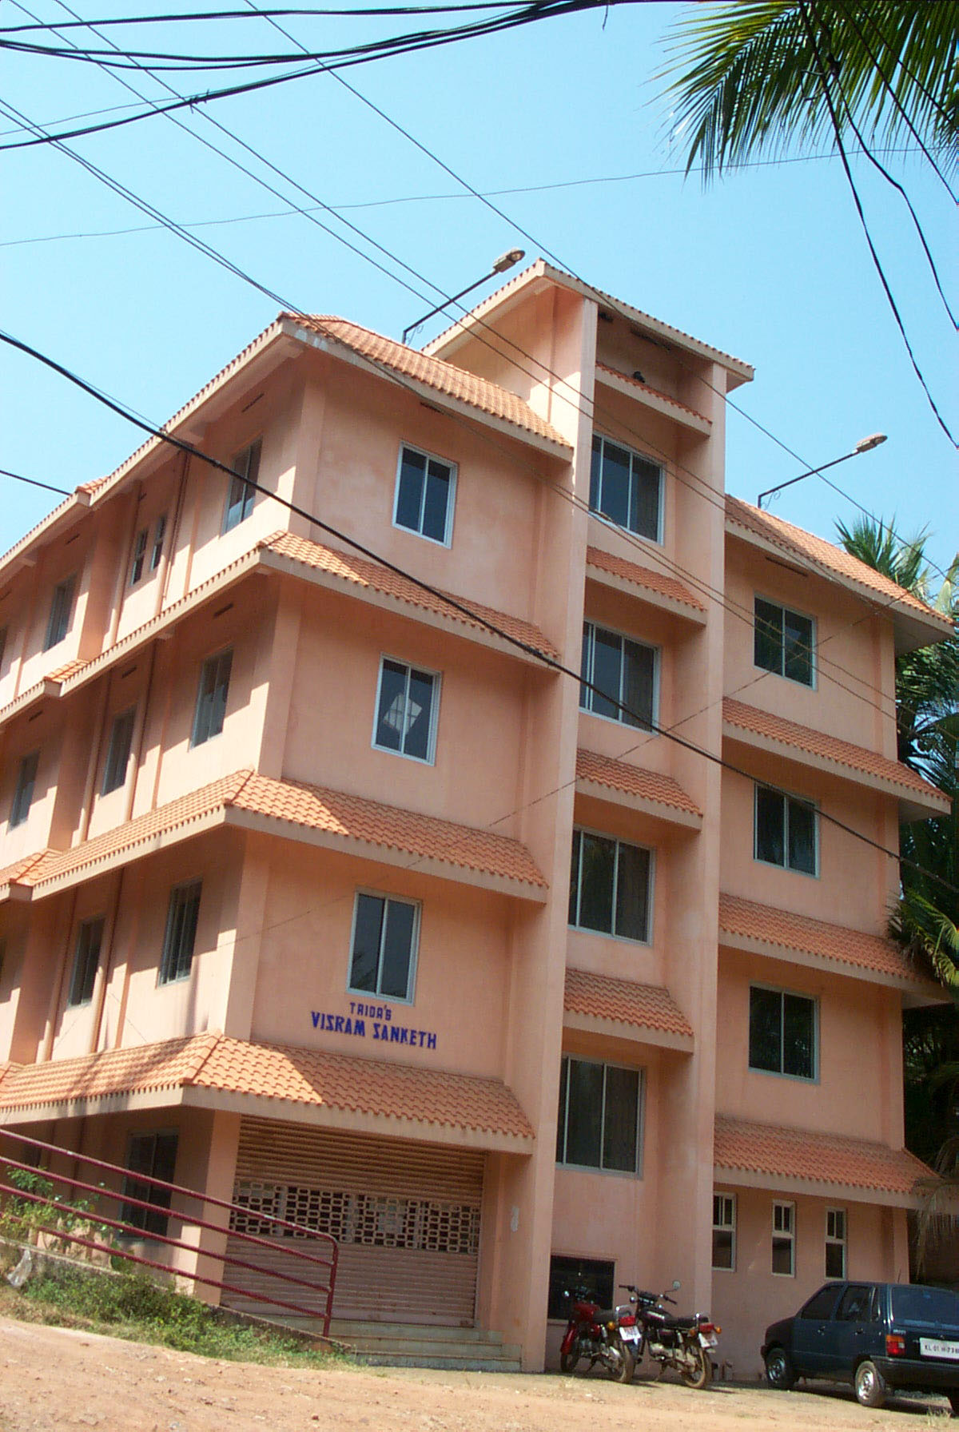

ADMINISTRATION REPORT

2009-2010

Administration Report 2009-2010

INDEX

Sl. No | Subject | Page No.
 | TRIDA – A profile | 3
 | Organisational Chart | 5
 | Human Resources | 6
 | Functions of various wings of TRIDA Administrative wing | 8
 | Revenue wing | 8
 | Planning wing | 14
 | Engineering wing | 18
 | Accounts wing | 26
 | Internal control system | 26
 | Budget Estimate for 2009-10 | 29
 | Implementation of Right to Information Act | 31

Thiruvananthapuram Development Authority

- TRIDA – A PROFILE

The city of Thiruvananthapuram, the abode of Lord Padmanabha and the capital of many Royal Kings and the Capital city of the state of Kerala is a very beautiful city with its enchanting beaches. Buildings nestling against coconut palms, royal palaces, monuments recognized as marvels in architecture with its equitable climate and natural abundance of forests has gained importance in the national and international arena not only as the dream tourist destination but also as the centre of knowledge and alternative information system hub of the country. Easy accessibility and better connectivity with the rest of the world has made it a commercial and tourist gateway to the state. All of us desire that this prime city should grow in an orderly manner and remain a pleasant and healthy place to live in. This desire can materialize only by proper planning. The above purpose can be achieved only by preparing long term plans for the growth and development of Thiruvananthapuram and guiding the development activities along those lines. Thiruvananthapuram Development Authority (TRIDA) is constituted for the implementation of planned and scientific development of Thiruvananthapuram city and adjoining area. The jurisdiction of the Authority extends to the Thiruvananthapuram Corporation and 10 surrounding Panchayaths TRIDA was constituted in the year 1980 under section 53 A of the Travancore Town Planning Act 1108 (IV of 1108) as per GO (MS) 111/1980/LA & SWD dt.15/05/1980.
Government of Kerala has decided that the TRIDA shall be the agency responsible for the long term planning and development of Thiruvananthapuram city and as a statutory authority in the place of trust under the provisions of section 53 (A) of the Town Planning Act 1108. The primary object of constituting TRIDA is to look after the smooth and orderly implementation of the sanctioned master plan for Thiruvananthapuram. Besides it also takes implementation of various detailed Town Planning schemes.
Its main function is the preparation of Town Planning Schemes in consultation with the State Town and Country Planning Department within its area of jurisdiction and for implementing the proposals contained in the schemes. TRIDA also controls the developmental activities in the region to ensure that it is in a planned and scientific manner. This results to an integrated development of the area. The main tool for carrying out this function in an orderly manner is the sanctioned Master Plan for Thiruvananthapuram. It also co-ordinate the public and private sectors for developmental activities. The Authority has been vested with ample powers under the Act and Rules for the proper discharge of these functions.

Thiruvananthapuram Corporation is the major urban centre and the area of jurisdiction of the Development Authority includes area of TVPM Corporation and Ten Panchayaths surrounding the Thiruvananthapuram Corporation. Details of Local Bodies included under the Jurisdiction of TRIDA are shown in the next page.

- Table : 1 -TRIDA : Area and Jurisdiction

Sl. No. | Name of Local Body | Area in Sq.Km | Population as per 2001 census
I | URBAN LOCAL BODIES
1 | Thiruvananthapuram Corporation | 141.55 | 744983
II | PANCHAYATHS
 | Kalliyoor | 17.23 | 36836
 | Kazhakutam | 19.47 | 34131
 | Kudappanakunnu | 7.69 | 38175
 | Pallichal | 21.70 | 45118
 | Sreekariyam | 20.73 | 49145
 | Vattiyoorkavu | 10.61 | 41890
 | Venganoor | 10.61 | 41890
 | Vilappil | 19.42 | 33372
 | Vilavoorkal | 12.02 | 27495
 | Vizhinjam | 12.62 | 47170
 | Total | 293.65 | 1140205

- FUNCTIONS

- Planning : | Preparation and revision of Master Plan and Zonal Development plans
- Regulation and control: | To regulate and control the development through statutory plans and other measures
- Development : | To undertake various developmental projects in the Developmental Area
- Co-ordination: | To co-ordinate with other public agencies concerned with provisions of Urban infrastructure, services and amenities.

ORGANISATIONAL CHART

CHAIRMAN & GENERAL COUNCIL AND EXECUTIVE COMMITTEE
MEMBER SECRETARY
Administration
Planning
Revenue
Engineering
Accounting
AO & RO
SO
Assistants
Typist
Driver
Peon
TP
DY.TP
ATP
Assistants
AO & RO
Assistants
CE
EE
AEE
AE
DB
Overseers
Assistants
AO
Assistants

THIRUVANANTHAPURAM DEVELOPMENT AUTHORITY
ESTABLISHMENT SCHEDULE
(DETAILS OF POSTS AS ON 31-03-2010)
Sl.  No. | Name of Posts |  | Sanctioned |  | TRIDA own staff | Deputation | Vacant
1. | Chairman (Ex-Officio) |  | 1 |  | - | 1 | 0
2. | Secretary |  | 1 |  | 0 | 1 | 0
3. | Chief Engineer |  | 1 |  | 1 | 0 | 1(LWA)
4. | Town Planner |  | 1 |  | 1 | 0 | 0
5. | Accounts Officer |  | 1 |  | 0 | 1 | 0
6. | Executive Engineer |  | 1 |  | 1 | 0 | 0
7. | Asst. Executive Engineer/  Technical Assistant |  | 2 |  | 2 | 0 | 1 LWA Vacancy filled  0
8. | Asst. Executive Engineer (Electrical) |  | 1 |  | 0 | 0 | 1
9. | Deputy Town Planner |  | 1 |  | 1 | 0 | 0
10 | Asst.Town Planner |  | 2 |  | 1 LWA | 1 | 1(LWA)
11. | Asst. Engineer/Head Draftsman |  | 4 |  | 2+1=3 | 0 | 1 (Deputation GCDA)  1 vacant
12. | Revenue & Administrative Officer |  | 1 |  | 1 | 0 | 0
13. | Asst. Engineer (Electrical) |  | 1 |  | 0 | 0 | 1
14. | Section Officer |  | 1 |  | 1 | 0 | 0
15. | Senior Grade Assistant |  | 4 |  | 2+2=4 | 0 | 2 Deputation from TRIDA to KSBC
16. | Asst.Grade - I |  | 4 |  | 0 | 4 | 0
17. | Asst.Grade - II |  | 4 |  | 1 | 3 | 0
18. | Confidential Asst.Grade - I |  | 2 |  | 0 | 0 | 2
19. | Senior Grade - Typist |  | 1 |  | 1 | 0 | 0
20. | Typist Grade - I |  | 1 |  | 0 | 0 | 1
21 | Typist Grade – II |  | 1 |  | 0 | 1 | 0
22. | Telephone Operator cum Information Asst. |  | 1 |  | 0 | 0 | 1
23. | Architectural Draftsman Grade– I |  | 1 |  | 0 | 0 | 1
24. | Overseer/D’man Grade I |  | 3 |  | 0 | 0 | 3
25. | Overseer/D’man Grade II |  | 5 |  | 0 | 0 | 5
26. | Overseer/D’man Grade II (Electrical) |  | 1 |  | 0 | 1 | 0
27. | Surveyor Grade II |  | 1 |  | 1 | 0 | 0
28. | Overseer Grade III (Ele) |  | 2 |  | 0 | 0 | 2
29. | Driver Grade I |  | 2 |  | 1 | 0 | 1(Deputation to Kudumbasree)
30. | Driver Grade II |  | 3 |  | 0 | 0 | 3
31 | Blue Printer |  | 1 |  | 0 | 0 | 1
32 | Chainman |  | 2 |  | 0 | 0 | 2
33. | Roneo Operator |  | 1 |  | 1 | 0 | 0
34. | Daffedar |  | 1 |  | 1 | 0 | 0
35. | Peon |  | 5 |  | 0 | 2 | 3
36. | Watcher |  | 1 |  | 0 | 0 | 1
37. | Gardener |  | 1 |  | 0 | 0 | 1
38. | Full-time Sweeper cum Cleaner |  | 1 |  | 0 | 0 | 1
 | Total |  | 68 |  | 23 | 15 | 30
 |  | Sanctioned strength  TRIDA own staff  Deputation various Dept.  Vacant |  | : 68  : 23  : 15  : 30

FUNCTIONS OF VARIOUS WINGS OF TRIDA

Secretary is the Head of the Institution and also the Estate Officer. Sri.B.Dileep Kumar, Joint Director of Urban Affairs is holding the post of the Secretary, TRIDA on deputation. The Secretary is supported by Heads of various wings.

  - ADMINISTRATIVE WING:
Administrative and Revenue officer is the head of the General Administration of TRIDA. All papers relating to establishment and general administration is routed through her. From 1.04.2009 to 11.10.2009 Smt. Mary Judith, Section Officer, TRIDA was holding the full additional charge of Administrative and Revenue Officer. From 12.10.2009 onwards she was promoted as the Administrative and Revenue Officer. As per the establishment schedule the details of posts such as, sanctioned post and filled up are furnished in page No: 6 and 7

  - REVENUE WING:

Administrative & Revenue officer is the Head of the Revenue section of TRIDA. She is the authority of the Revenue collections and all the works connected with revenue. From 1.04.2009 to11.10.2009 Smt. Mary Judith, Section Officer, TRIDA was holding the full additional charge of Administrative and Revenue Officer. From 12.10.2009 onwards Smt.Mary Judith was the Administrative and Revenue Officer. The main source of Revenue of TRIDA is the rent collection from different shopping complexes of TRIDA.

The Organisation has a well equipped multi-functional group representing various branches of urban planning and implementation of schemes viz., town planning, engineering, revenue, accounts, administration, public relations, etc. The Member Secretary is the Head of the institution supported by Heads of various wings. The various section heads are Planning wing headed by Town Planner, Engineering wing headed by Chief Engineer, Administration and Revenue wing headed by Administrative and Revenue Officer, Accounts wing headed by Accounts Officer.

The sanctioned strength of TRIDA consists of 68 employees including Chairman (Ex-officio) out of which the employees strength of TRIDA as on 31.03.2010 is 38 consisting of 15 deputationist and 23 own employees of TRIDA. The remaining 30 posts are lying vacant.

The Chairman, General Council and Executive Committee constitute the Authority. The General Council is the policy making body and has a strength of not less than 15 and not more than 30 members excluding the Chairman. The Executive Committee is responsible for giving effect to the policies laid out by the General Council as per the provisions of the Act. The Strength of the Executive Committee shall not be less than 5 and not more than 10 members excluding Chairman. The General Council review the actions of the Executive Committee in implementing the policies adopted by the General Council from time to time.

The last Executive Committee of this report year was held on 27.03.2010 Sri. C. Ajayakumar is the Chairman of TRIDA from 8/08/2007 onwards.

- Table : 2- List of General Council Members up to 31-03-10

Sl  No | Name | Designation and Address | Contact Numbers
 | Sri. C Ajayakumar | Chairman. | Mob  Off  Res | :  :  : | 9846441059  2728671  2441059
 | Sri. C.Jayan Babu | Mayor,  Corporation of Thiruvananthapuram | Mob  Off  Res | :  :  : | 9447377477  2322470  2478844
 | Sri. Panniyan Ravindran | Member of Parliament,  Thiruvananthapuram | Mob  Off  Res | :  :  : | 9447032655  2331771
 | Sri. V. Sivankutty, | MLA  Thiruvanathapuram East | Mob  Off  Res | :  :  : | 9846660986  2512209  2478334
 | Sri.V Surendran Pillai, | MLA  Thiruvananthapuram West | Mob  Off  Res | :  :  : | 9447008224  2512256  2430288
 | Sri.N.Sakthan, | MLA  Nemom | Mob  Off  Res | :  :  : | 2512358  2358289
 | Adv.George Mercier, | MLA  Kovalam | Mob  Off  Res | :  :  : | 9447055460  2512318 2305460
 | Sri. M.A Vaheed , | MLA  Kazhakoottam | Mob  Off  Res | :  :  : | 9447343460  2308999 2307437
 | Sri. Anavoor Nagappan | President, District Panchayat,  Thiruvananthapuram | Mob  Off  Res | :  :  : | 9447746371  2440890  2275371
 | Sri. A. G. Sasidharan Nair | Private Secretary & Nominee of Sri. M Vijayakumar  Hon’ble Minister for Law and Parliamentary affairs. | Mob  Off  Res | :  :  : | 9447031717  2333460  2431717
 | Adv. Harilal | President,  Block Panchayath,  Thiruvananthapuram | Mob  Off  Res | :  :  : | 9847795403  2573045
 | Sri. A. P Murali | President,  Sreekaryam Grama Panchayat,  Thiruvananthapuram | Mob  Off  Res | :  :  : | 9387221355  2598392  2419493
 | Sri. Mudavan Mugal Rajasekharan Nair | Chairman, Works Standing Committee,  Corporation of Thiruvananthapuram | Mob  Off  Res | :  :  : | 9447694060 2320821 2725633
 | Sri Edayar Sadasivan | Member  TC. 30/1934  Kattil Veedu,  Bhagatsingh road, Pettah P O  Thiruvananthapuram | Mob  Off  Res | :  :  : | 2130111  6536099
 | Sri. E G Mohanan | Member  TC.41/131, “Saras”  Chire Home Lane,  Kowdiar,Thiruvananthapuram | Mob  Off  Res | :  :  : | 2326687  2437727
 | Sri. B Sudhir | Chairman, Institute of Architects  Thiruvananthapuram | Mob  Off  Res | :  :  : | 9895533999  6533999  2322720
 | Sri. Sanjay Kaul, I A S | District Collector  Thiruvananthapuram | Mob  Off  Res | :  :  : | 9447700222  2462471  2338746
 | Sri. Eapen Varghese | Chief Town Planner  Thiruvananthapuram | Mob  Off  Res | :  :  : | 9447021429  2321429  2557178
 | Sri. P.K Satheeshan | Chief Engineer,  PWD (Roads) | Mob  Off  Res | :  :  : | 9847065747  2322346  2725089
 | Sri. S K Sundaran | Chief Engineer,  PWD (Buildings and Local works) | Mob  Off  Res | :  :  : | 9447122946  0471-2322946
 | Sri. Johnson K George, IAS | Secretary,  Thiruvananthapuram Corporation | Mob  Off  Res | :  :  : | 9447044141  2332085  2573745
 | Sri. R. Sukumaran | Chief Engineer  Kerala Water Authority | Mob  Off  Res | :  :  : | 9447798484  2322313  2723848
 | Sri. K Balachandran | Chief Engineer (Distribution)  Kerala State Electricity Board | Mob  Off  Res | :  :  : | 9446008011  2461565  2452559
 | Sri. S D Jayaprasad | Secretary,  Kerala State Pollution Control Board | Mob  Off  Res | :  :  : | 9447975700  2318151  2435187
 | Sri. P.M. Muhammadali | Managing Director, KURDFC | Mob  Off  Res | :  :  : | 9447062802  3259126
 | Sri. B Dileep Kumar | Member Secretary | Mob  Off  Res | :  :  : | 9447402121  2726515  2332730

- Table: 3- List of Executive Committee members
up to 31-03-10

Sl.  No. | Name | Designation
 | Sri.C. Ajayakumar | Chairman
 | Sri.C.Jayan Babu | Worshipful Mayor,  TVPM Corporation.
 | Sri.V.Sivankutty | MLA, Thiruvananthapuram East
 | Sri.V.Surendran Pillai | MLA Thiruvananthapuram West
 | Sri.Anavoor Nagappan | President,  District Panchayat, TVPM
 | Sri.Sanjay Kaul IAS | District Collector  TVPM.
 | Sri.Edayar Sadasivan | Member
 | Sri. P.K.Satheesan | Chief Engineer (Roads)
 | Sri.Eapen Vargheese | Chief Town Planner
 | Sri.R.Sukumaran | Chief Engineer,  Kerala Water Authority
 | Sri.B.Dileepkumar | Member Secretary

SHOPPING COMPLEXES OWNED BY TRIDA

Sl. No | Name of shopping complex | No. of shops etc | Total  Current Demand
Sl. No | Name of shopping complex | No. of shops etc | Rent |  | Maintenance charge
 | Kedaram Shopping complex at Kesavadasapuram | 79 shops  1 restaurant space  11 stores  1 office space | 5936997 | 297018
 | Mini shops Attakulangara | 40 | 43320
 | Temporary Rehabilitation Block,behind Saphallyam | 11 | 25107
 | Vijayamahal Lodge | 14 | 15327
 | Mini shops Kesavadasapuram | 12 | 76644
 | Mini shops at Medical College | 10 | 80791
 | Mini shops at Palayam | 12 | 208849
 | TRIDA centre near Medical College  Lease rent (TRIDA centre, Rehabilitation block, Kedaram) | 55 nos of shops and 3 office spaces | 34511
 | Rehabilitation Block at Medical college | 30 shops and 2 office space | 3280584
 | Saphallyam shopping complex at Palayam | 76 | 4740832
 | Saphallyam (Lease) | 9 |  | 235698
 | Palayam phase II | 12 | 517964
 | Rehabilitation block near central stadium | 7 | 161848
 | Temporary Rehabilitation block at Palayam | 50 | 469345
Other Buildings owned by TRIDA

1 | TRIDA Main office near Police Head Quarters
2 | Vishram Sanketh at Thampanoor
3 | Vishram Sanketh at Medical College

The total demand (Arrear) for 2009-2010 is Rs. 97,68,121/-. And current demand is Rs. 1.61.24.835/-. Out of which an amount of Rs. 15,44,030/- and Rs.1,43,04.916/- has been collected towards arrear and current demand respectively. The balance amount to be collected is Rs. 82,24,091/- as arrears and Rs. 18,19,919 as current. Out of which an amount of Rs. 31,53,454/- is pending for Revenue Recovery and Rs. 32,51,508/- on cases.
- Palayam Urban Renewal Scheme

The traders within the Palayam Urban Renewal Scheme area who are to be rehabilitated in the C block building as per the agreements executed between them and TRIDA has filed WP (C) No.4074/06 before the Hon’ble High Court against the Security Deposit and rent fixed by TRIDA for the ‘C’ block building and the Hon’ble High Court has appointed Sri. M.R.Gopala Krishnan Nair, retired District Judge as Adjudicator for fixing the reasonable Security Deposit and Rent and also to fix the location and area for the two land owners who have not received compensation for their land acquired by TRIDA in WP(C) 5168/06. Adjudication proceedings started on 10.04.2006.As directed by the Hon’ble High Court the traders deposited 1/10th of the Security Deposit already proposed by TRIDA and participated in the Adjudication Process. As per the Proceedings of the Adjudicator, traders along the MG road handed over the keys and moved to the new premises. TRIDA handed over the land for road widening after demolishing the old structures.

The Adjudication process continued till 13-02-08. On 31/01/08 the Hon’ble Adjudicator has fixed the rent and Security Deposit to be remitted by the allottees of ‘C’ block building on rehabilitation. As per the Judgement, in WP © 4074/2006, of Hon’ble High Court, has directed to fix the Rent and Security Deposit by using the criteria “ no loss, no profit basis”. But the Adjudicator has fixed the rent on the basis of PWD norms as per GO (MS) No.16/95 PW and T dtd.09-03-95 and 12 months rent as Security Deposit. If this norms accepts, this will cause huge loss to TRIDA. Since this order is against the criteria of “no loss no profit”, TRIDA forced to file appeal before the Hon’ble High Court against the order of the Adjudicator. The appeal is WP© 12723/08 TRIDA. As directed by the Hon’ble High Court the tenants of the C block building has remitted the part rent during December 2009. As per order dated 21st December 2009, the Hon’ble High court has appointed Sri.M.R. Gopalakrishnan again as adjudicator to fix the rent liability of the tenant of Block ‘C’ of the shopping complex in Palayam on the basis of the norms fixed by the Hon’ble Adjudicator on 31-01-2008. Hon’ble Adjudicator has submitted the statement regarding the rent liability of tenants. The matter is pending before the Court.

Details of write off losses /waiver of revenue during the year
In 1985 TRIDA has disbursed house loan to various low income groups for the construction of houses. Interest and Penal Interest arrears due in respect of Sri.R. Vijayan, Vadakeperakathu Veedu, Punchakari, Thiruvallam, Thiruvananthapuram and in respect of Smt. Thulasi Bhai, Krishna Thulasi, T.C.No.17/1227-1, Sasthanagar, Pangode, Thirumala were waived as per G.O(MS)No. 2180/09/LSGD dated 24/8/2009 and G.O(MS)No.3039/2009/LSGD dated 17.11.2009 respectively. In addition to these, arrears due in respect of EWS scheme was written off as per G.O(MS)No.21/2009/Housing dated 20.05.2009.
Arrears of Revenue as per DCB (House Loan)
Out of Rs.70,93,967/- towards the total demand of House Loan disbursed to various sections of society by TRIDA, an amount of Rs. 5,57,354/- have been collected and an amount of Rs. 65,36,613/- is outstanding for the current year.

PLANNING WING

Town Planner is the Head of this wing. Sri. Dinesh is the Town Planner in the year 2009-10 up to 15.02.10.On relieving Sri S.Dinesh to join in Thiruvananthapuram Corporation Office as Town Planning Officer under working arrangement , Smt. B.Geetha, Deputy Town Planner is holding full additional charge of the Town Planner and continuing in the position . There is only a skeletal technical staff in the planning wing with only one A.T.P in addition to the Dy. Town Planner. Development plans and detailed Town planning schemes are prepared under the provisions of the Travancore Town planning Act 1108 (1933 A.D) The intention to prepare a scheme for a particular area is published as per section 7 of the Town Planning Act. The Town Planning Department have been requested to prepare the scheme on behalf of Trivandrum Development Authority.
The development plans and detailed Town planning schemes designates land for various uses. This is marked in the scheme map with different colours or notations.
TRIDA is the agency setup for the implementation of Scheme provisions. This is achieved through co-ordination between various Government and non Government agencies and implementing certain projects envisaged in the scheme when no other agency is available to do so.
Statutory function under various Act and Rules
Development plans and Detailed town planning schemes are prepared under the provisions of the Travancore Town Planning Act 1108. The intention to prepare a scheme for a particular area is published as per section 7 of the Town planning Act. The Town planning Department is requested to prepare the scheme on behalf of the Thiruvananthapuram Development Authority. After the implementation of the Kerala Municipalities Act, consequent to the 74th Amendment Act, the implementation of the Kerala Building Rules in 1999 planning and regulatory function of TRIDA is limited.

Details of acquisition made:
Name of scheme | Extent of land acquired till 31.3.2009 | Extent of land acquired till 31.3.2010
Widening of 12 roads under CRDP | 98% | 99.6%

Details of cases filed / disposed /pending:

 | Filed | Disposed | Pending
Kerala Lok Ayukta | 5 | 0 | 5
Munciff court | 4 | 0 | 4
High court | 29 | 0 | 25
Ombudsman | 2 | 0 | 2

Details of LAR cases filed / disposed /pending:

Total Number in Lower Court | Disposed | Pending | No. of Appeals filed | Disposed | Pending
385 | 185 | 200 | 52 | 14 | 38

Details of progress of Major schemes under preparation

  - DTP Scheme for Kowdiar area: - This scheme was published on 12.03.96. Remarks on objections and suggestions in Form 14 were forwarded to CTP for remarks on 05.09.2000. CTP returned the Form 14 on 12.06.2003 for certain corrections. The rectified Form 14 was forwarded to CTP and on 09.12.2008. Collection of ownership details are almost completed.
  - DTP Scheme for Kochar Road:-This scheme was published on 19-01-91. Remarks on objections and suggestions were forwarded to CTP on 23.11.2001 for remarks.
  - DTP Scheme for NH Byepass: - This scheme (5 schemes) was published on 30.02.1991. Out of the 5 schemes scheme 1 was forwarded to Government through the CTP on 08.02.2001. CTP returned the scheme on 13.02.2002 for corrections and the work is pending with TRIDA. The remaining 4 schemes also pending with TRIDA.
  - DTP Scheme for Power house road: - This scheme was published on 09.07.92. Scheme forwarded to Government for sanction on 29.01.2002. Follow up with Government
  - DTP Scheme for Fort area: – This scheme was published on 09.01.92. Requested the CTP on 20.1.2009 to advice TRIDA regarding the further course of action
  - DTP Scheme for Thirumala area: - This scheme was notified on 07.06.1996. Requested CTP to advice TRIDA regarding the further course of action 0n 09.01.2009.
The above D.T.P scheme works were kept pending as per the oral direction and a letter were forwarded to Government for suitable set up.
Details of progress of Major projects under implementation:

- Trade centre cum Bus station project at Kazhakootam:- Sanction accorded for acquisition on 18.01.2005. Requisition forwarded in Jan 2005. Since LA action became denova, revised requisition forwarded on 03.10.2008 Even though site inspection completed and follow up action was made with LA unit.
- Vellayambalam-Thycaud road: – Requisition forwarded on 24.11.2006. Follow up with revenue authorities. Revenue surveywork is completed and all details in connection with 4 (1) notification were collected in LA unit and the work is in DD stage.
- Chalai Project: The fresh requisition for acquisition for the balance land to be acquired for which the award was quashed earlier by the Hon’ble High court Fresh requisition was forwarded to the District Collector on 28.02.2008 and demarcation by stone planting and joint inspection with revenue authorities were completed. Follow up with revenue authorities. 4(1) notification was published on 8.05.2009.Valuation of 40 Number of structures were taken. The work is in DD stage in the office of special Thahsildar ,Additional Unit.
- Truck terminal project:- Truck terminal project at Mankeezh junction was sanctioned vide G.O.(Rt) no.5226/95/ LAD dt. 15.09.1995 for acquisition of 10 Acres of land. A concept plan was prepared and forwarded to Government on 17.09.2009 for the revision of G.O and exempting 1.85 Acres of fully developed portion from the proposed area.
- Medical college Sub Centre:- Revised G.O, for the handing over of balance land ,was obtained and close follow up action were done with LA unit for the transfer of land to TRIDA.

Details of work done on new schemes
- The alignment in respect of the widening of Peroorkada – Mannarakonam road was prepared after conducting total station survey and forwarded to KRFB for approval.
- The Junction improvement plan for Vattiyoorkavu junction was forwarded to Government through C.T.P .
- .Junction Improvement project for Medical College .Junction was prepared and submitted to government for approval.
- .Junction Improvement project for Thirumala Junction were prepared and submitted to government for approval.
- A proposal for commercial acquisition at Bakery junction was suggested and forwarded to government for sanction.
- A proposal for Satellite town and Affordable Housing were drafted.
- Development Plan for Attukal Area. One more meeting of technical and advisory committee was convened on 14-12.2009 for promoting the scheme.
- Development Plan for Veli Area: – It was decided to prepare development plan for Veli area but nothing done so far.

‘Vision 2030’ – Seminar on preparation of second Master Plan for TCR.
TRIDA in association with Department of Town & Country Planning, District Panchayat, Corporation of Thiruvananthapuram and EDIT had organized a two day Seminar on ‘VISION 2030’ at Kanakakunnu Palace, Thiruvananthapuram on January 29, 30, 2009. The main objective of the seminar was to gather views and suggestions to be incorporated in the Second Master plan envisaged for the development of the various sectors. Experts from various fields, senior officials from various departments, elected representatives and Ministers of LSGD, Law & Parliamentary Affairs participated in the Seminar and rendered valuable suggestions and opinions. Proceedings and recommendations of the seminar were submitted to Government for approval.
Issue of NOC to Land Assignment applications
25 cases of NOC applications for land assignment received from the District Collector were examined and issued NOC.
Progress in computerization: A new printer, Cannon-lazer shot printer LBP 3108B is purchased in this financial year.
Assistance to the Vigilance and Anti Corruption cell of the state
Assistance was given to the Vigilance and Anti Corruption cell of the state while conducting raid at the office of the Corporation of Trivandrum was made available as and when required up to 15.02.10 and also provided site inspection report
Providing information to the General Public
Information on any questions relating to Master Plan and DTP Schemes were given to the public on an average 5 enquiries daily.

ENGINEERING WING

ACHIEVEMENTS OF THE YEAR 2009-’10

Chief Engineer is the Head of this wing. In the report year Sri. R. Ajit, Executive Engineer, TRIDA was holding full additional charge of Chief Engineer. The Engineering Wing of TRIDA comprises of Civil Engineering section, Electrical Engineering section and Drawing Branch headed by the Chief Engineer supported by Executive Engineer, Assistant Executive Engineers, Assistant Engineers, Overseers, Draftsmen and Apprentice trainees.
The major achievements of the Engineering wing during the year 2009-2010 are the following.

A. COMPLETED/ ONGOING PROJECTS

- Road widening under Capital Region Development Programme :
Additional survey, demarcation and planting of boundary stones were done in certain corridors under CRDP as approved by the Empowered Committee. In the case of acquisition from private property valuation of the structures affected had to be assessed. A large number of revised valuations were done and the valuation certificates forwarded to various Land acquisition officers in time despite shortage of field staff.
- Construction of balance works of ‘C Block’ at Palayam:
As per GO (Rt) No.24/09/LSGD dtd.03-01-08, the balance works of the rehabilitation block (‘C’ Block) at Palayam was awarded to Kerala State Nirmithi Kendra at an amount of Rs.171.60 lakhs excluding statutory charges. The proposed work consists of construction of balance portion of the basement and other 3 floors. The total area of C block is 6048 m² .
Agreement was executed between TRIDA and Kerala State Nirmithi Kendra on 20-02-2009 for the construction of ‘C’ block. The work is in progress and there is a Managing Committee which meets every month to closely monitor and review the progress of the work. The work is expected to be completed by May 2010.
3) ‘Boat House Renovation’ project at Vallakadavu
The renovation of the Vallakadavu boathouse, one of the prized heritage monuments in the City dating back to the Travancore era, has been entrusted to TRIDA by the Department of Tourism. Government had accorded sanction for the restoration of Boat House at Vallakkadavu as part of the Environmental Improvement Project and its execution was entrusted to TRIDA. The estimated cost of the project was Rs.90 lakhs. The restoration of the work was done in 2 stages: sub-structure and super-structure works. Substructure had been completed long ago and the work on the buildings, which form the superstructure, has been completed during the year under report. The work involved reconstruction of the original structures based on the design approved by the Tourism Department. Reconstruction of a two storied tile roofed building of total built up area of 600 sq m including a mezzanine floor of 225 sqm has been completed and procedures to hand over the site to Tourism Department are going on. Five boats can be operated at a time. Funds for the project were given by Tourism Department and Urban affairs Department amounting to Rs.45 lakhs and 22.5 lakhs respectively. Additional fund to the tune of Rs. 11 lakhs is required for making payment to the contractor on the Final bill and Architect on the consultancy fee. This has been addressed to the Tourism Department. Action has been taken for handing over the project to Tourism Department.
4) Reconstruction of Baker road
Baker road is a 12 metre wide road for a length of 180 metres from the Sunnymede lane to Jacob’s Junction built on embankment with random rubble retaining wall on either side. A portion of the road for a length of about 10 meters and width of about 3 meters along with a portion of the retaining wall on the eastern side collapsed due to sub soil erosion and settlement. Government have entrusted the reconstruction work to TRIDA.

After conducting soil investigation and other studies at the site, we got the design prepared by the College of Engineering, Thiruvananthapuram for the reconstruction of Retaining wall over RCC pile foundation. The length of the retaining wall is 40m for an average height of 3.85m. The estimated cost of construction was Rs.36 lakhs. Administrative Sanction for the above work was accorded by the Executive committee held on 19/06/08. The work was tendered as per PWD procedures. It was awarded to the contractor Sri. R.K.Prasad @ 27% above E/R and the agreement was executed on 24/07/08. Meetings of the Technical Experts were also convened whenever required to sort out certain site issues. Arrangements were also made to shift the nearby manholes and sewer line by K.W.A for ensuring safety to the embankment and retaining wall. The work has been completed by May 2009.
5) Construction of drains and culverts at Kavery Gardens, Kuriathy
TRIDA made a study on the flooding at Kavery Gardens at Kuriathy and prepared an estimate amounting to Rs. 25 lakhs and submitted to District Collector for sanction. Vide Order No. 16666/09/MPLADS(08-09)/DPO/TVPM dated 28/02/2009 District Collector accorded administrative sanction to TRIDA for implementing the above work under MPLADS 2008-09.The proposal is to widen and deepen the drain starting from Kavery Gardens at Kuriathy providing sufficient slope and to join with the PWD main drain at Bypass road. The PWD drain will also be reconstructed by deepening and widening for a length of about 80m and finally connected to the new drain that will be constructed by KWA for sewage over flow. The work was tendered on 03.07.2009 giving wide publicity. Consequently agreement was executed with the contractor Sri Abdul Hakkim on 21. 08.2009. Major portion of the work amounting to Rs. 16 lakhs has been completed as first stage. Next stage can be commenced after only the completion of the over flow conduit in the NH Bypass by KWA.

6) Mini shops at Medical College Scheme area
As part of rehabilitation of the traders affected by the ‘Bus stand project’ near Medical College junction TRIDA proposed to construct a row of shops of plinth area 110 sqm adjacent to the existing TRIDA centre at Medical College area at an estimated cost of Rs. 7,00,000/. The Executive Committee held on 30.07.2009 accorded administrative sanction for this project. The work was tendered and as per PWD procedures. It was awarded to the contractor Sri.Abdul Hakkim @ 25% above estimated amount and the agreement was executed on 28.12.2009. The work has been completed by March 2010. Rent and Security deposit to be collected from the tenants have been worked out and obtained approval from the Executive Committee of TRIDA held on 09.04.2010. Steps have been taken for conducting public auction of shops
7) Construction of compound wall, gate and road work at Visram Sanketh at Medical College Scheme area
As part of special maintenance of visram sanketh and nearby internal road in the Medical College TRIDA scheme area an estimate was taken which amounted to Rs.2,30,000/-. Administrative Sanction was accorded on 11.08.2209. The work was tendered and as per PWD procedures it was awarded to the contractor Sri.Abdul Hakkim @ 25% above estimated amount and the agreement was executed on 28.12.2009. The works of gate and compound wall have been completed by March 2010. Road work has been kept pending for want of final judgment of Hon’ble Ombudsman for LSGD.

8) Maintenance of the Assets of TRIDA
In addition to the construction projects and road widening projects the Engineering wing also attended the maintenance of the buildings including cleaning, gardening etc in the scheme areas of Palayam, Kesavadasapuram, Medical College, the office building at Vazhuthacaud and vehicles of TRIDA. All the periodical maintenance and up gradation required at various substations in the shopping complexes are done properly. Annual Maintenance has been done to the lifts and DG sets at Kedaram and Saphallyam complexes. Special maintenance work such as replacing of fibre roof is proposed at Saphallyam. Construction of Compound and gate infront of Saphallyam Complex has been tendered.

9) Other works
Chief engineer is issuing technical sanction to various local bodies all over Kerala for the estimate of their projects by collecting scrutiny fee @ 0.75% of the estimated cost. This contributes additional revenue to TRIDA. We have issued Technical Sanction on 18.06.2009 for the following works:
- Nehru Park at Paravur Municipality for an amount of Rs.22,35,000/-
- Mini Crematorium at Paravur Municipality for an amount of Rs.22,10,000/-

B. NEW PROJECTS/ WORKS

i) Bus stand cum commercial complex at Medical College

As per G.O(Rt)No.4420/08 LSGD dt. 26.12.2008 Administrative Sanction was accorded for an amount of 440 lakhs for the work - construction of Bus stand cum shopping complex at TRIDA’s land near Medical College Junction. A Technical committee consisting of five Chief Engineers for examining tenders and estimates was formed based on the decision of TRIDA Executive Committee dated 30.07.2009.
The Technical committee held on 29.10.2009 approved estimate for an amount of Rs. 317 lakhs (Rs. 31700000/-) for the civil works of the above project.The work was tendered as “two cover system” on 31.10.2009. One tender received from M/s. Thermofab Insulations was rejected by the Technical Committee held on 15.12.2009 since the firm (Thermofab Insulations) did not satisfy the pre-qualification conditions.
The work was re-tendered on 25.01.2010 on ‘two Cover system’. Two tenders were received. The Technical Committee held on 10.03.2010 examined the pre-qualifications of the tenders and found that both tenders were satisfying prequalification conditions. Subsequently, the price bid was opened and found that ‘Cheeran’s Structurals’ quoted the lowest rate; ie 25% above Estimate rate. As per the decision of TRIDA’s Executive Committee held on 27.03.2010 Hon’ble Chairman of TRIDA negotiated with ‘Cheerans Structurals’ on 31.03.2010 to reduce the rate.
But Cheerans structurals informed that considering the hike in the sand price and construction materials and higher labour charges, further deduction in the quoted rate was near difficult for them. TRIDA Executive Committee held on 09-04-2010 decided to request the Government to accept the tender @ 25% above Estimate rate. The fund for the project shall be mobilized by collecting rent/security deposit from the tenants and loan from financial institutions. We have requested Government to accept the tender @ 25% above Estimate rate quoted by M/s. Cheeran’s Structurals, Thiruvananthapuram.

ii) Rehabilitation block at Pettah on BOT basis
As part of road widening under Capital Region Development Programme an old two-storied building at Pettah Market belonging to Corporation of Thiruvananthapuram has to be demolished. Inorder to rehabilitate the traders, TRIDA has prepared a project at an estimated cost of Rs. 45 lakhs on BOT basis and forwarded to Corporation for approval. The proposal consists of a commercial complex of two floors of total area 358m² accommodating 19 small shops in the Ground floor and 7 office spaces in the first floor with toilet facility. As per GO(Rt) No.1669/2009/LSGD dtd 06.07.2009 Govt have accorded Administrative Sanction for ‘the construction of shopping complex at an estimated cost of Rs. 45,50,270/- by the Corporation of Thiruvananthapuram’ through TRIDA on BOT basis. The work was tendered on 07.12.2009. The Executive Committee of TRIDA held on 29.01.2010 accepted the lowest negotiated offer from a Contractor Sri.A. Abdul Hakkim @ 22.5% above estimated PAC of Rs. 41,98,000/-. Agreement was executed on 17.04.2010 and the work was commenced on 20.04.2010.

iii) Rehabilitation block at General Hospital Junction
Government have transferred 10 cents of land from the compound of RMO quarters at General Hospital Junction for the rehabilitation of traders affected by road widening under Capital Region Development Programme at General Hospital Junction. It is proposed to construct a multi-storied shopping complex at an approximate cost of Rs. 100 lakhs. Govt vide GO(Rt) 2285/09/LSGD dtd 08.09.2009 accorded sanction to TRIDA for accepting quotation submitted by Architect Consortium @ 3% of the estimated amount. Accordingly TRIDA executed agreement with the Architect on 16.09.’09. Discussions were held with the affected traders for finalisation of the area to be allotted to them. Soil test has been conducted through College of Engineering, Trivandrum. Architectural plan has been finalized and the design and estimate are under preparation

iv)Setting up of office space for Ombudsman at Saphallyam complex

As per the request of Ombudsman TRIDA has prepared an estimate amounting to Rs.22,00,000/- and Executive Committee of TRIDA held on 29/09/2009 accorded administrative sanction for the same. Civil works for Rs.10,90,700/- is proposed to be executed by TRIDA and other works such as electrification, computer networking will be carried out through PWD electrical wing and Keltron respectively. The work had to be tendered three times. TRIDA’s Executive Committee held on 27.03.2010 decided to accept the lowest tender of 29% above estimated rate quoted by Sri.M.N.Gopalakrishnan Nair with the approval of Government.

v) Metalling and tarring of Baker road, Palayam

As per the sanction of the Executive Committee on 19.06.2008 construction of an RCC retaining wall and other works has been carried out by TRIDA. In continuation to this work, metalling and tarring of Baker road have to be carried out. Estimate has been prepared, which amounts to Rs. 6,00,000/- ( Rupees: Six Lakhs only ) . The Executive Committee of TRIDA held on 29.01.2010 accorded Administrative Sanction for this project. The work has been tendered on 06.04.2010.

vi) Palayam Urban Renewal Project
TRIDA intend to develop the balance land at Palayam as a ‘commercial hub’ project. The proposed project which will consist of a separate multi level car parking facility to accommodate more than 500 cars at a time besides basement level car parking facility in each block has a social objective to reduce traffic issues at Palayam. The complex will provide for World class shopping mall, multiplexes, restaurants, recreation hubs, office spaces etc. Since it is not practical to think of such a mega project to the tune of Rs. 265 crores to be implemented by TRIDA, it is proposed to develop the entire land on BOT basis with the participation of INKEL. The initiative of TRIDA, Corporation of Thiruvananthapuram and INKEL is intended to create a signature building which will be a land mark for Thiruvananthapuram City. The advantage of BOT approach is that it combines responsibility for usually disparate functions-design, construction and maintenance-under a single entity and ensures expedited completion compared to conventional project implementation methods. Discussions are being held between InKEL, TRIDA and TMC at Government level to work out the terms and conditions under which project can be implemented.

ACCOUNTS WING
Accounts officer is the head of Accounts wing. Smt.Deepa L.S, Municipal Secretary is officiating as the Accounts Officer on deputation Smt. Anuja who was relieved of her duties as Account Officer on 31-10-2008 handed over charge to Smt.Mary Judith, Section Officer, TRIDA continued to hold charge of Accounts Officer till 15-01-2009 when Smt.Deepa L.S, Municipal Secretary, Paravoor Municipality joined duty in the post and Smt.Deepa L.S is continuing as such. The Annual Accounts of TRIDA for the year 2008-09 is prepared as per the provisions (See Rules 56 and 58) of the Development Authority Rules.

Internal control system

A strategic and sound internal control system is functioning in TRIDA. An Assistant is specifically authorized to work as the Internal Auditor of TRIDA, with a view to precheck all claims for payment including work bills. Defects / discrepancies noticed on verification are got rectified through the concerned officers who recommends the payments. The bills are scrutinized and submitted to the Secretary for sanction of payments through the Accounts Officer.
Audit of Accounts of TRIDA upto the year ended on 13-03-2009 has been conducted by the Accountant General. Steps were taken to waive all the objections raised in audit and majority of the paras were get dropped. The Audit committee headed by the Secretary with the Chief Engineer, Town Planner and Administrative / Revenue officer as its members and Accounts Officer as convener discusses the issues related to the Audit paras and steps to be taken to clear the audit paras.

A. Finance Summary
Brief narrations of various features of the accounts for the year 2009-2010 are furnished below.
A |  | (Rupees in lakhs)
 | Total receipt 2009-10 | 735.280
 | Opening Balance | 279.845
 | Total | 1015.125
 | Total Expenditure 2009-10 | 793.649
 | Closing Balance | 221.48

B Receipt from Government
During the report year an amount of Rs.24000000/- was received from Government to meet the liability of LAR cases and works related to shifting of Office of Ombudsman and CRDP rehabilitation. The details are listed below.
Sl. N0 | Go.No. and Date | Amount | Purpose
1 | Go (Rt) No.3173/09/LSGD | 7500000 | For the satisfaction of court verdicts on LAR cases related to land acquisition
2 | Go (Rt) No.1096/2010/LSGD dtd.27-03-2010 | 12500000 | To satisfy Court verdict on LAR cases related to Land Acquisition
3 | Go (Rt) No.1068/10/LSGD dtd.26-03-2010 | 2200000 | For carrying out the work related to the shifting of office of the OMBUDSMAN for Local Self government Institution to Saphallyam complex, Palayam
4 | Go (Rt) No.1055/10/LSGD dtd.26-03-2010 | 1800000 | Fund towards Rehabilitation under city road improvement programme
 | Total | 24000000

C. TRIDA Debenture

TRIDA has paid an amount of Rs.2.875 lakh as interest on Bonds during the report year. Interest on bonds is paid promptly.
The following are the debentures floated by TRIDA
Name of bond | Face value (Rs) | Date of Maturity
11.5% TRIDA debenture 2010 | 5000000.00 | 28/08/2010
12% TRIDA debenture 2011 | 7500000.00 | 11/12/2011
Total | 12500000
The 11.50% TRIDA debentures 2009 with face value of Rs.50 lakhs matured on 28-08-2009 was paid on 31-12-2009.
Due to the shortage of fund we could not redeem 11.50% TRIDA 2010 with face value of 50 lakh matured on 28-08-2010.
D. Debt servicing:-
The principal amount of debt to various financial institutions during the end of the year comes to Rs.631.03 lakhs as shown below.
Sl.No. | Description | Principal Amount ( in lakhs)
a | KURDFC | 631.03
 | Total | 631.03
Steps are being taken to reduce the liability on debentures and that of KURDFC.

- BUDGET ESTIMATE FOR 2009-10
Receipts: The Budget Estimate for 2009-10 provides for Receipts and Expenditure to the tune of Rs.4993.786 and Rs.4602.839 lakhs respectively. The projection is based on Government grant, contribution from Local bodies, rent and lease money from buildings and Receipts expected from the proposed BOT schemes at Palayam and Chalai. Efforts will be taken to auction the remaining commercial space and to clear rent arrears.
Expenditure: The Expenditure proposed in the Budget estimate is for the completion of the on going development works as well as the proposed works. Borrowings: An amount of Rs.1600 lakhs is proposed to be mobilized as loan from Bank to be used for the completion of remunerative works.
Debt Servicing: The debt service burden to various financial institutions and Government comes to Rs. 3529.99 lakhs comprising of repayments to TRIDA debenture, KURDFC, and Government. These debts are to be paid from the monthly collection of rent and Government assistance. An amount of Rs.631.03 lakhs, liability of TRIDA to HUDCO has been taken over by the KURDFC. The entire amount is overdue to KURDFC. An amount of Rs.800 lakhs is due to TRIDA as centage charge from the local bodies within the Jurisdiction of TRIDA. Part of this amount will be used to settle the dues of KURDFC and the balance is proposed to be settled out of the revenues of TRIDA. The matter has already been taken up with the Government. Prudent and wise principles of Financial propriety are followed to limit the revenue Expenditure.
Centage charge from local self Government Institutions

Centage charges from Local Self Government Institutions also includes a major revenue of TRIDA. Centage charges to be received from Thiruvananthapuram Corporation for the period 1994-95 to 2009-10 is calculated as Rs.76327933 out of this an amount of Rs.44687531 is received as centage charge from Thiruvananthapuram corporation (ie Rs.2252000 for 1994-95, Rs.6260225 for 2006-07 Rs.4201828 for 2008-09 and Rs.5179800 as lease amount paid to Saphallyam for 2006-07, Rs.25793678/- adjusted for property tax of buildings owned by TRIDA (for and on behalf of centage charge) up to the period of 2008-09 2nd half on 2008-09. Thus till this date total amount of Rs.43687531 is received as centage charge from Thiruvananthapuram Corporation. Balance centage charge due from Thiruvananthapuram Corporation is Rs .32640402.
Apart from this centage charge from Grama Panchayat till 2009-10 comes to Rs.3655836. Out of this Rs.122992/- received from Kudappanakunnu Grama Panchayat, Rs.111234/- from Kazhakoottam Grama Panchayat during 2009-10 and `. 222653/- from Sreekariyam Grama Panchayat.
B Receipt from Government
During the report year an amount of Rs.10000000/- was received from Government to meet the liability of KURDFC. The details are listed below.
Sl. N0 | Go.No. and Date | Amount | Purpose
1 | Go (Rt) No.3173/09/LSGD | 7500000 | For the satisfaction of court verdicts on LAR cases related to land acquisition
2 | Go (Rt) No.1096/2010/LSGD dtd.27-03-2010 | 12500000 | To satisfy Court verdict in LAR cases related to Land Acquisition
3 | Go (Rt) No.1068/10/LSGD dtd.26-03-2010 | 2200000 | For carrying out the work related to the shifting of office of the OMBUDSMAN for Local Self government Institution to Saphallyam complex, Palayam
4 | Go (Rt) No.1055/10/LSGD dtd.26-03-2010 | 1800000 | Fund towards Rehabilitation under city road improvement programme
 | Total | 24000000

C. TRIDA Debenture
TRIDA has paid an amount of Rs.2.875 lakh as interest on Bonds during the report year. Interest on bonds is paid promptly.
The following are the debentures floated by TRIDA
Name of bond | Face value (Rs) | Date of Maturity
11.5% TRIDA debenture 2010 | 5000000.00 | 28/08/2010
12% TRIDA debenture 2011 | 7500000.00 | 11/12/2011
Total | 12500000
The 11.50% TRIDA debentures 2009 with fare value of Rs.50 lakhs matured on 28-08-2009 was paid on 31-12-2009.
Due to the shortage of fund we could not redeem 11.50% TRIDA 2010 with face value of 50 lakh matured on 28-08-2010.
D. Debt servicing:-
The principal amount of debt to various financial institutions during the end of the year comes to Rs.631.03 lakhs as shown below.
Sl.No. | Description | Principal Amount ( in lakhs)
a | KURDFC | 631.03
 | Total | 631.03
Rs. 12500000 paid to KURDFC during 2009-10 as interest steps are being taken to reduce the liability of debentures and that of KURDFC.

Implementation of Right to Information Act

Appellate Authority - Sri.B.Dileep Kumar,
Secretary,TRIDA

Public Information Officer - R.Ajit
Executive Engineer, TRIDA

Assistant Public Information Officer - 1. Mary Judith,
(01-04-2009 to 11-10-2009)
Section Officer, TRIDA
2. Smt.Kumari Jayasree
Section Officer, TRIDA
(12-10-2009 to 31-03-2010)

Total number of Applications received - 95 cases
Total disposed - 95 cases
Pending - Nil
Penalties received - Nil
Suo Moto disclosures - Nil
No. of Appeals received - Nil

